S2 – SELECT FROM TABLE

# What you will know:

SELECT – WHERE OR/AND, IN, - ORDER BY

Open ([this online SQL editor](https://www.w3schools.com/sql/trysql.asp?filename=trysql_op_in)) Press Ctrl+Click

Look at the content of the **Products** table, using a SQL command or by clicking on the link on the right side

**Q1**

Show the name and the price of the products which price is greater or equal than 20.00

**Expected columns:**

|  |
| --- |
| ProductName |

**Your query:**

****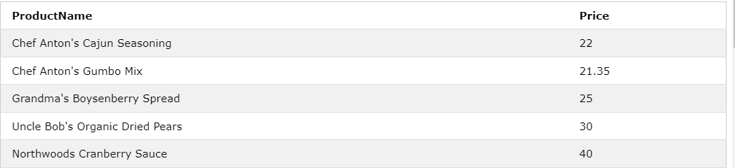

Q2 Write SQL query to get all product that has price less or equal then 10, and make the product name arrange as alphabet (A-Z)

|  |  |
| --- | --- |
| ProductName | Price |

**Expected Columns:**

**Your query:**



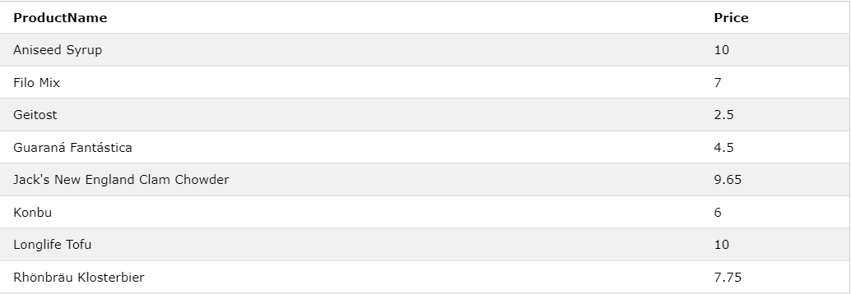

Q3 Write SQL to display all records of Products that has price range (less or equal than 10) and (greater or equal than 20).

The price should display from the most expensive to the cheaper one in the list.

**Expected column:**

|  |  |
| --- | --- |
| **ProductName** | **Unit** |

**Your query:**

……………………………………………………………………………………………………………………………………………………………………………………………………………………………………………………………………………………………………………………………………………………………………………………………………………………………………………………………………………………………………………………………………………………………………………………………………………………………………………………

Q4 By using **customers** table, show all details about customers living in USA, in one of the following cities:

* Seattle
* San Francisco
* Portland
* Eugene

**Expected columns:**

|  |  |  |
| --- | --- | --- |
| CustomerName | City | Country |

**Your query:**



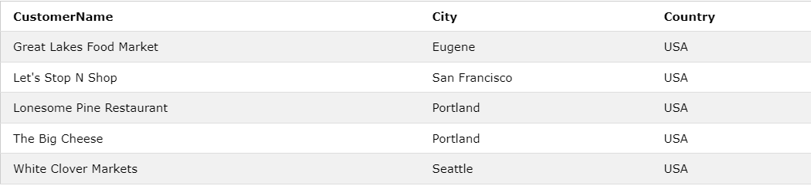

**Q5** Displaydetail information of all customers that are from the same countries as the suppliers:

Expected columns:

|  |  |  |  |  |  |  |
| --- | --- | --- | --- | --- | --- | --- |
| ID | CustomerName | ContactName | Address | City | PostalCode | Country |

**Your query:**



